**Installing VS Code for Chromebook**

When you go to Visual Studio Code website to download it for your Chromebook, you will see it to install it for a lot of Operating Systems, but not for ChromeOS. Here are the steps that you can follow to install Visual Studio Code in you Chromebook.

Note:

*This is for the Chromebook with* ***Intel Processor.***

Let’s Begin ☺

**Step 1:** Open settings in your Chromebook. You will see something as shown in image below.

**Step 2:** Now Expand Advanced and Select Developers option. After selecting Developers, you will find something as shown in the image.

**Step 3:** Now, in developers, you can see Linus development environment, there, click on “Turn On”.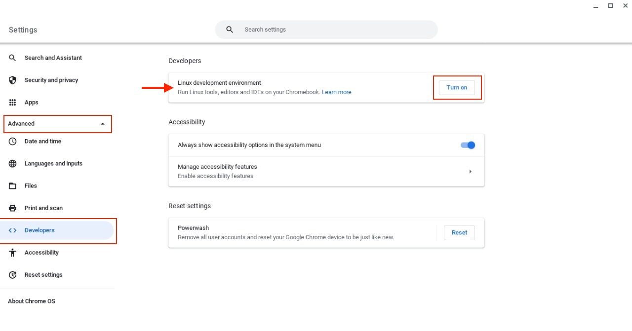

**Step 4:** After you click on Turn On, you will see an option to **Set Up Linux development environment.**

Click on Next.

**Step 5:** After you have clicked on Next, it will ask you for the username, enter the username that you want to give and the disk size you want to allocate. Here I am allocating 7GB, feel free to allocate as much space as you want. Then click **Install.**

**Step 6:** After you have selected Install, you will see a screen with **“Installing Linux”**. Wait for Linux to install in your system.

**Step 7:** After you have installed, you can see something like as shown in the figure. This suggests that you have successfully installed Linux in your system.

**Step 8:** Now go to the application and you can find **Terminal** under **Linux apps.** Open Terminal once and then close it.

**Step 9:** After you have installed Linux, go to [code.visualstudio.com/download](https://code.visualstudio.com/download) and download the **.deb** file.

**Step 10:** After you have downloaded the .deb file, go to **Downloads**, Right Click on the .deb file and select **Install with Linux**.

**Step 11:** After you have stated installing successfully, you will get a message indicating that installation started successfully and a progress bar, showing the installation of the application.

**Step 12:** After the application has been installed successfully in your device, you can go to applications, and you can find Visual Studio Code installed on your device.

**Step 13:** Now, you can open Visual Studio Code, and enjoy coding ☺

